PRODUCT DETAILS

**AURA SWISS LADIES WATCH J5.639.M** 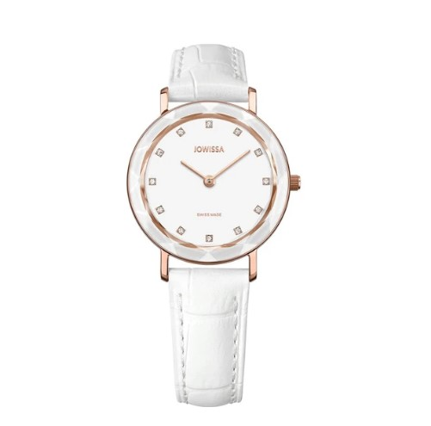

**€219.90**

**Specifications**

**Movement**: Ronda Swiss quartz movement with hours, minutes as well as long battery life span

**Dial**: Enamelled look

**Time indicator**: 12 applied rhinestones as hour indices

Hands: Filament

**Watch case:** Stainless steel

**Case surface**: Gloss polished with a rose-gold plating

**Back case**: Stainless Steel back cover, easy battery replacement

**Case diameter**: 30.5 mm

**Case height**: 7 mm

**Water resistance**: 5 ATM (shower-proof)

**Watch glass**: Tempered mineral glass with diamond-cut bezel

**Bezel**: Metallized, integrated in the glass

**Strap material**: alligator-embossed genuine leather strap with pearled effect

**Band width**: 15 mm

**Buckle**: Stainless steel with laser-engraved logo

**Adjustment range**: Wrist circumference of 145-190 mm

**Interchangeable band**: Yes, with quick release

**Gender**: Female

**Swiss made**: Hand-assembled in Switzerland

**Color**: Rose / White

**Reference**: J5.639.M